**GoliathWeb IIS Site Configuration & Binding Disclaimer**

Goliath Performance Monitor (GPM) utilizes Microsoft IIS Web Server to host the GPM website, named "GoliathWeb". Any changes made to the website, other then adding a valid certificate, are not supported. Making changes to any of the Microsoft IIS web server or "GoliathWeb" site settings can impact GPM's URL access, agent connectivity, reporting, and more. GPM also does not support being on a shared Microsoft IIS Web Server.

If you decide to edit the "GoliathWeb" site binding to add in your own certificate, please ensure that you do not change any other binding settings. The binding must remain to be configured as follows:

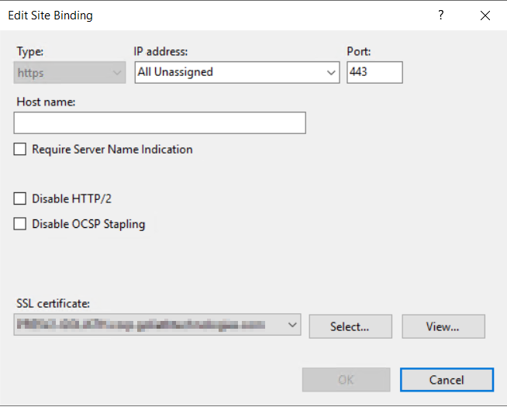

(Note how in the image above no boxes are checked, there is no host name defined and the ip address field is set to "all unassigned")